**Opzet Heuristiek Amstelhaege**

Huisjes op een veld programmeren

Huisjes verplaatsen

Kijken of totale waarde groter is geworden

Constraints checken

Plotje maken

Functie die waarde berekent maken

Voor morgen:

* Chantal: Huisjes op een veld programmeren - Hoe moet dat?
* Maurice: Uitzoeken wat constraints precies zijn
* Jet: Huisjes verplaatsen + plotje maken uitzoeken

**Jet**

*Wat is een plot:*

A **plot** is a [graphical technique](https://en.wikipedia.org/wiki/Graphical_technique) for representing a [data set](https://en.wikipedia.org/wiki/Data_set), usually as a [graph](https://en.wikipedia.org/wiki/Graph_of_a_function) showing the relationship between two or more variables. The plot can be drawn by hand or by a mechanical or electronic [plotter](https://en.wikipedia.org/wiki/Plotter). Graphs are a visual representation of the relationship between variables, very useful for humans who can quickly derive an understanding which would not come from lists of values. Graphs can also be used to read off the value of an unknown variable plotted as a function of a known one. Graphs of functions are used in [mathematics](https://en.wikipedia.org/wiki/Mathematics), [sciences](https://en.wikipedia.org/wiki/Science), [engineering](https://en.wikipedia.org/wiki/Engineering), [technology](https://en.wikipedia.org/wiki/Technology), [finance](https://en.wikipedia.org/wiki/Finance), and other areas.

Plots play an important role in [statistics](https://en.wikipedia.org/wiki/Statistics) and [data analysis](https://en.wikipedia.org/wiki/Data_analysis). The procedures here can broadly be split into two parts: quantitative and graphical. Quantitative techniques are the set of statistical procedures that yield numeric or tabular output.

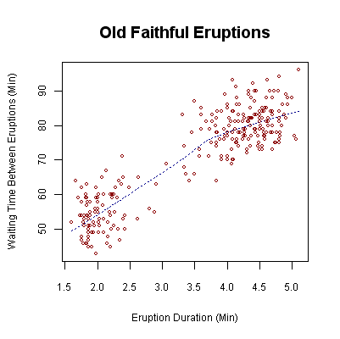

Graphical procedures such as plots are a short path to gaining insight into a data set in terms of testing assumptions, model selection, model validation, estimator selection, relationship identification, factor effect determination, outlier detection. Statistical graphics give insight into aspects of the underlying structure of the data.

Bron: https://en.wikipedia.org/wiki/Plot_(graphics)

← Voorbeeld van grafiek met plots.

Hoe een plotje maken:

<https://plot.ly/python/scattermapbox/>

# Matplotlib Python Tutorial Part 1: Basics and your first Graph!

<https://www.youtube.com/watch?v=wAwQ-noyB98>

Handige handleiding ‘Basic Beginners’ Introduction to plotting in Python’:

<http://www.ast.uct.ac.za/~sarblyth/pythonGuide/PythonPlottingBeginnersGuide.pdf>

Matplotlib documentation:

<http://matplotlib.org/contents.html>

Algoritmes om te gebruiken:

Constraint relaxation

CSP: <https://en.wikipedia.org/wiki/Constraint_satisfaction_problem>

Constraint programming:

<https://en.wikipedia.org/wiki/Constraint_programming>

*Voor presentatie:*

in Python schrijven (geen andere talen)

Kunnen al beginnen met functions (ook voor algoritme) bedenken/uitdenken, classes aanmaken etc.

upper- en lowerbounds berekenen

constrained optimization problem